|  |  |  |  |  |  |
| --- | --- | --- | --- | --- | --- |
| **Entry** | **Date** | Time | Duration | Location | Title |
| 1 | 14/02/23 | 12-2pm | 2 | Home | EOI |
| 2 | 28/02/23 | 2-4pm | 2 | AUT | Workshop 1 |
| 3 | 01/03/23 | 2-4pm | 2 | Home | Meeting Schedule |
| 4 | 06/03/23 | 6pm-8pm | 2 | AUT | Kick-off Meeting |
| 5 | 08/03/23 | 11-12pm | 1 | AUT | Meeting |
| 6 | 08/03/23 | 2-4pm | 2 | AUT | Workshop 2 |
| 7 | 09/03/2023 | 11-1pm | 2 | Home | Team Contract |
| 8 | 14/03/2023 | 9-12:30pm | 3.5 | AUT | Meeting |
| 9 | 14/03/2023 | 1-2pm | 1 | AUT | Documents |
| 10 | 14/03/2023 | 2-4pm | 2 | AUT | Workshop 3 |
| 11 | 16/03/2023 | 1pm-2pm | 1 | JadCup | Client Meeting |
| 12 | 17/03/2023 | 4pm-7pm | 3 | Home | Documents |
| 13 | 18/03/2023 | 9am-11am | 2 | Home | Meeting/Documents |
| 14 | 18/03/2023 | 12pm-1pm | 1 | Home | Documents |
| 15 | 21/03/2023 | 9:30am-10am | 0.5 | AUT | Meeting |
| 16 | 21/03/2023 | 10am-11am | 1 | AUT | Meeting |
| 17 | 21/03/2023 | 11am-1pm | 2 | AUT | Documents |
| 18 | 21/03/2023 | 2pm-4pm | 2 | AUT | Workshop 4 |
| 19 | 23/03/2023 | 10am-1pm | 3 | Home | Documents |
| 20 | 24/03/2023 | 9am-12pm | 3 | Home | Meeting/Documents |
| 21 | 24/03/2023 | 12pm-1pm | 1 | Home | Documents |
| 22 | 25/03/2023 | 9am-12pm | 3 | Home | Meeting |
| 23 | 26/03/2023 | 12pm-2pm | 2 | Home | Documents |
| 24 | 27/03/2023 | 12pm-2pm | 2 | Home | Documents |
| 25 | 28/03/2023 | 10am-11am | 1 | AUT | Meeting |
| 26 | 30/03/2023 | 3:30pm-5pm | 1.5 | Home | Meeting |
| 27 | 01/04/2023 | 9am-11am | 2 | Home | Meeting |
| 28 | 4/04/2023 | 10-11am | 1 | AUT | Meeting |
| 29 | 4/04/2023 | 2.15pm-3.15pm | 1 | AUT | Project Proposal |
| 30 | 08/04/2023 | 9:30am-12pm | 2.5 | Home | Meeting |
| 31 | 09/04/2023 | 1:30pm-6pm | 4.5 | Home | Upskilling |
| 32 | 10/04/2023 | 11am-3pm | 4 | Home | Upskilling |
| 33 | 11/04/2023 | 2pm-4pm | 2 | Home | Meeting |
| 34 | 12/04/2023 | 9am-11am | 2 | Home | Upskilling |
| 35 | 13/04/2023 | 12pm-2pm | 2 | Home | Upskilling |
| 36 | 14/04/2023 | 12-2pm | 2 | Home | Upskilling |
| 37 | 14/04/2023 | 3:30pm-4pm | 0.5 | Home | Meeting |
| 38 | 14/04/2023 | 12:30pm-5:30pm | 4 | Home | Upskilling |
| 39 | 16/04/2023 | 1pm-3pm | 2 | Home | Upskilling |
| 40 | 18/04/2023 | 2pm-4pm | 2 | Home | Upskilling |
| 41 | 21/04/2023 | 3:30pm-4pm | 0.5 | Home | Meeting |
| 42 | 22/04/2023 | 9:30am-11:30pm | 2 | Home | Meeting |
| 43 | 22/04/2023 | 12pm-5pm | 5 | Home | Upskilling |
| 44 | 24/04/2023 | 10am-12pm | 2 | Home | Upskilling |
| 45 | 29/04/2023 | 9:30am-12:30pm | 3 | Home | Meeting |
| 46 | 02/05/2023 | 10:30-11am | 0.5 | AUT | Meeting |
| 47 | 02/05/2023 | 2pm-4pm | 2 | AUT | Working |
| 48 | 06/05/2023 | 9:30am-11am | 1.5 | Home | Meeting |
| 49 | 09/05/2023 | 9:30am-10am | 0.5 | AUT | Meeting |
| 50 | 09/05/2023 | 10-11am | 1 | AUT | Meeting |
| 51 | 12/05/2023 | 4pm-6pm | 2 | Home | Documents |
| 52 | 13/05/2023 | 9:30am-12pm | 2.5 | Home | Meeting |
| 53 | 16/05/2023 | 10am-11am | 1 | AUT | Meeting |
| 54 | 16/05/2023 | 11am-1pm | 2 | AUT | Meeting |
| 55 | 16/05/2023 | 3pm-4pm | 1 | AUT | Workshop |
| 56 | 20/05/2023 | 9:30am-12pm | 2.5 | Home | Meeting |
| 57 | 23/05/2023 | 9:30am-12-30pm | 3 | AUT | Meeting |
| 58 | 23/05/2023 | 2pm-2:30pm | 0.5 | AUT | Meeting |
| 59 | 24/05/2023 | 2pm-4pm | 2 | Home | Documents |
| 60 | 26/05/2023 | 10am-3pm | 5 | Home | Documents |
| 61 | 27/05/2023 | 9:30am-12pm? | 2.5 | Home | Meeting |
| 62 | 30/05/2023 | 10am-10:30am | 0.5 | AUT | Meeting |

1. Expressions of interest forms were released alongside the potential projects. I spent the time to research each project and companies behind the external projects. From this I thought about what tech stacks might be used in each project. After selecting my top 5 projects and submitting I received the confirmation email.

2. Professor Jacqui and Dr Ramesh hosted the first workshop for all the Research and Development students. We were introduced to the R&D project outlines and what we can expect in part 1 and part 2. Key roles, expectations and working with external clients was covered which gave us a clear understanding on what can be expected.

3. I was assigned to the ‘Digital Twin’ project. We were emailed a confirmation alongside our mentor (Matthew Kuo). I emailed our team to organize a meeting and included Matthew, thankfully Matthew created a Microsoft Teams for us to use and an availability timesheet for us to fill out.

4. The group organized a meeting to introduce each other. We discussed team contract obligations and personal requirements for the group. I let the team know I would prefer not to stay at university late as my productivity reduces significantly into the late afternoon.

5. We met with Matthew and the whole group. He explained more about the project in detail and gave us a few things we need to focus on before the next week’s meetings. He gave us a Programmable Logic Controller (PLC) to take home as we will eventually need it to simulate the project. We discussed areas of research that we would need to do before next week’s meeting, such as the Tech stack, target framework to use (Agile etc.,).

6. Workshop 2 covered project proposals further and what was expected from us before week 6. Dr Ramesh and Professor Jacqui covered client meetings and what attitude we need to approach the client meeting with, this followed communication standards between the client and how we should approach them. Professional and courteous, replying to emails in a timely manner or letting them know we have received their correspondence. Required upskilling was mentioned to only be a week or two, which is surprisingly not enough in my opinion especially for a project such as ours. A list of proposal content was created, project management methodology, team roles, schedule and milestone report, risk and issues register, project success factors, and a disclaimer. We were briefed on that the final product is merely a research project and will not be working on a system in production.

7. This morning I reviewed our weekly goals, one being the team contract. I volunteered to complete this as I do not want to fall behind on documentation. I spent some time researching what makes a team contract and queried the team on anything personal they want to include inside the contract. I added in headings such as Commitments, Team Meetings, Problem Solving, Conflicts, and Meeting guidelines. I compiled a draft copy and uploaded this into our working document storage for the team to review.

8. We met Matthew again followed by a documentation catch up session. During the meeting we discussed and pointed out we are behind on our proposal documents. This was due to us only being able to meet the client in the third week. I created a list of documents which are reliant on the client meeting, and which are not. I delegated and split documents amongst the team. We agreed to start meeting on Saturdays from 9-12 to get the documents over the line. Following this we agreed to meet 30 minutes prior to compile a review of what we accomplished the week prior, this is to maximize our meeting time with Matthew and stay on track.

9. I worked on the ‘training plan’. This is required as the project is going to need new skills and new technology which the team members have not working with before. I identified core key skills such as Kanban methodology, JavaScript/React, Factory I/O, Programmable Logic Controllers (PLCs), Factory I/O Web APIs, NodeRed, SCADA and Databases. I compiled a list of sub skills as general outlines on what the team will work on. Each team member may or may not have skills in these areas which are identified by the skills matrix.

10. Workshop 3 expanded on project proposals. It covered what is necessary and feasible for the project. Key points covered   
Necessary : Project rational, projection objective, project scope.  
Feasible : Technical infrastructure, existing skills, missing skills and upskilling.  
Manageable : Schedule (2 semesters), is it possible?  
Dr Ramesh explained the importance of selecting a correct methodology or the project. This identifies project tasks and deliverables. The methodology provides projects with phases. Phases and tasks provide the ‘Work Breakdown Structure’. The idea of the WBS is to break a task into several independent sub-tasks.

11. Today we met the client Daniel with Matthew at the Jadcup factory. We were shown around the factory to be familiar with the process. Daniel showed us the machines alongside the PLC they used. We took notes and pictures of the metrics which were displayed on the user interface. These metrics are what we will need to replicate on the web dashboard. After the tour of the factory we sat down as Matthew needed to translate for us. We asked Daniel a set of questions we had written down previously to gather more information. We agreed as a minimum viable product that the web dashboard deliverable will just be reading the data and transferring that over to the web dashboard.

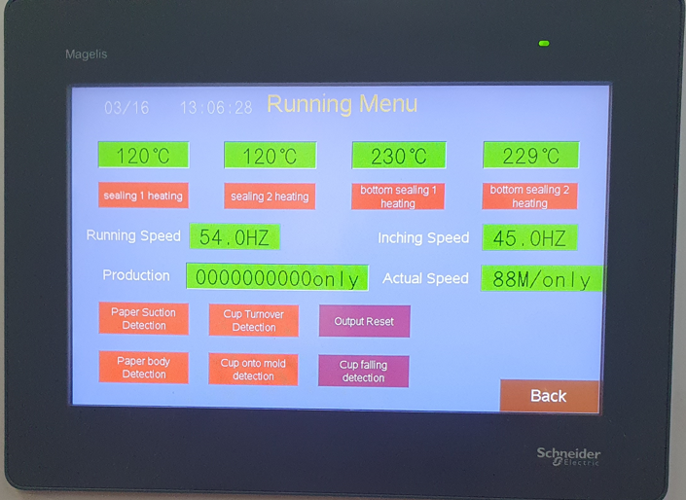

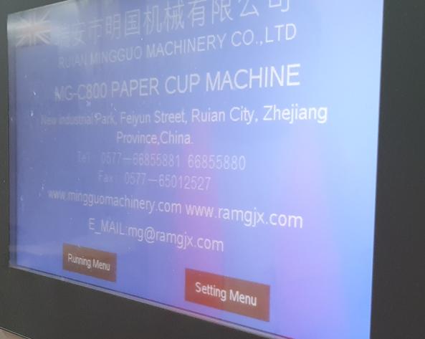

12. I was given the task of identifying the technical infrastructure of the project. I felt this was a little premature as some aspects of the project are still quite a grey area and will become evident over time. I spent time to research what was the best platform for each area of the project we have identified so far.   
Git: collaboration tool for version control and code management  
JavaScript/React: dynamic and responsive user interface capability for the web dashboard  
PLC’s: industry standard for machine programming and automation  
Factoryio: simulation software to replicate the factory environment  
Web API’s: communication between the factory and web dashboard  
NodeRED: open-source flow-based programming tool for the PLC  
Online Database: Secure and reliable storage for client login information  
Online Server: necessary for hosting the web dashboard  
IDE: VS Code

13. We held a meeting outside of work hours to complete documentation for the proposal. During the meeting, we discussed several areas that were still unclear and needed further attention. One of the issues we discussed was the leadership role in the project. In the previous meeting, Matthew had informally told me that I would be the project leader. However, in this meeting, Josh stated that he would like to continue being the project leader. While I would have been happy to continue leading the project as I feel that I am a good fit for a management position, we discussed the issue and came to a resolution.

We then went on to discuss team roles and how we would approach selecting Kanban as an appropriate methodology for the project. We brainstormed on the most appropriate tech stack for the project and created a small diagram of how the stack would work and fit together. During the discussion, we also identified our team member's strengths, weaknesses, and areas in which we would like to work on to learn more.

Finally, we delegated tasks, and I was assigned to work on the communication management plan. The plan will outline how we will communicate with stakeholders, including the client and how we will manage any potential issues that may arise during the project.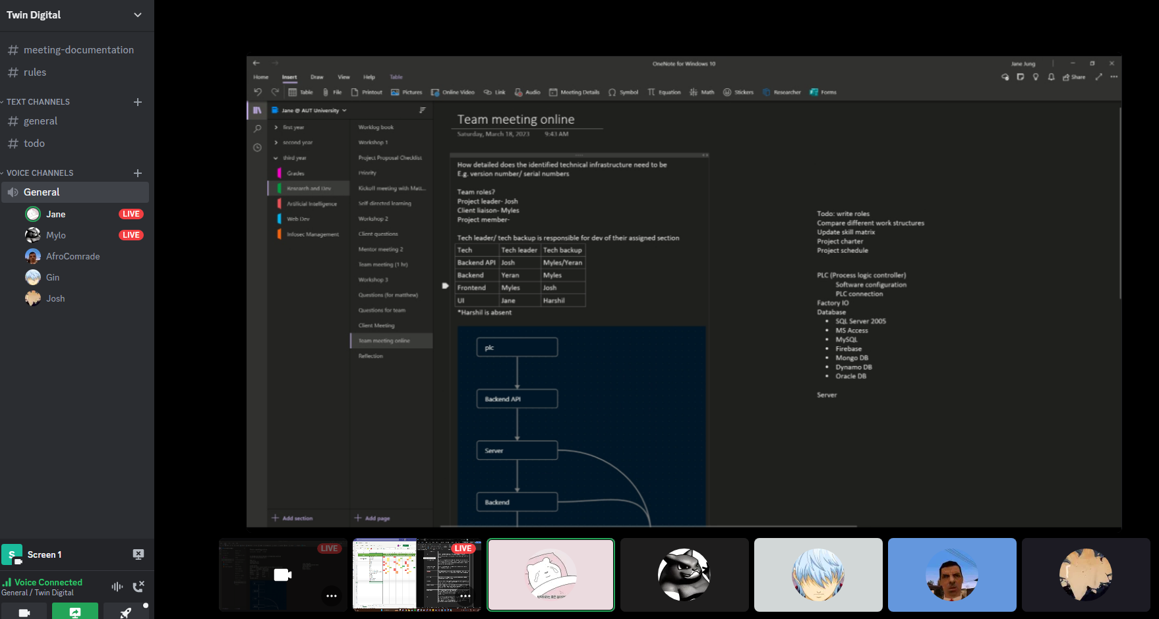

14. After reviewing the Change Management Plan that was provided as an example, I took the time to adapt it to fit our specific project needs. The updated plan is designed to provide a structured approach to managing changes and ensure effective communication throughout the project when changes occur. The document includes a detailed purpose of the change management plan, which outlines its key objectives and the benefits it will provide to our project. This section will help ensure that everyone involved understands the purpose of the plan and its importance. We also identified a clear process for submitting change requests, including the necessary forms and information required. This process will help ensure that change requests are submitted in a timely and consistent manner, with all the required information provided upfront. Once a change request is submitted, it will be reviewed by the project manager and technical lead, who will consider its size, complexity, and impact on the project. This review process will help ensure that changes are properly evaluated and only approved if they align with the project's goals and resources. To facilitate effective communication around changes, we have outlined a clear process for communicating changes to all stakeholders. This includes the rationale behind the change, its impact on the project, and any potential risks that may arise. The plan also includes a detailed implementation plan for approved changes, including a clear outline of the scope, schedule, budget, and required resources. This will help ensure that changes are properly implemented and that all team members are aware of their responsibilities. Finally, we have outlined a clear process for reviewing the results of any changes that have been implemented. This review will include an assessment of the change's impact on the project and its stakeholders, as well as any other relevant factors. This will help ensure that we can learn from any changes made and continually improve our processes moving forward.

15. We took the time to create a list of issues or unclear sections that we wanted to clarify with Matthew. We went through the list in detail to clarify and get some expertise on. We also conveyed that Josh wanted to remain team leader to Matthew, as that way he would be aware for future communication.

16. We went into this meeting with a list of issues and areas we wanted to talk about with Matthew regarding the proposal. We highlighted we were about a week behind. We went through proposal layout and what was required to include. We highlighted a list of priority sectors.

17. We continued the meeting in a research lab, WZ701. To work on documents, we had assigned the team. I began researching and working on the Terms of Reference and the Project Rationale, which seemed to have a lot of overlap and was initially unclear to me. The Terms of reference was boiled down to, the what, how, and who. In contrast the project rationale is the ‘why’ of the project. I began to make a start on these documents.

18. Workshop, NDA’s, Team Culture, Team agreement, conflict resolution  
Dr Ramesh covered team culture, the team agreement, and conflict resolutions strategies in the workshop. This highlighted non-technical importance whilst working throughout the project with one another. I felt as though I already knew the content of this workshop due to having work and industry experience already. However, some of the conflict resolution strategies were important and interesting to hear about.

19. I submitted a draft copy of the proposal to Matthew. He indicated areas which did not meet the criteria and needed more depth or clarification. One area was my documentation on the Terms of Reference and Project rationale. I needed to include more detail and reword the paragraphs to be less technical.

20. Team meeting / Documents

We met online on Saturday as we need to go over the proposal together. We went through each comment left my Matthew and decided the best plan of action to rectify any mistakes or areas which needed more attention. We went through each comment left by Matthew and completed tasks.   
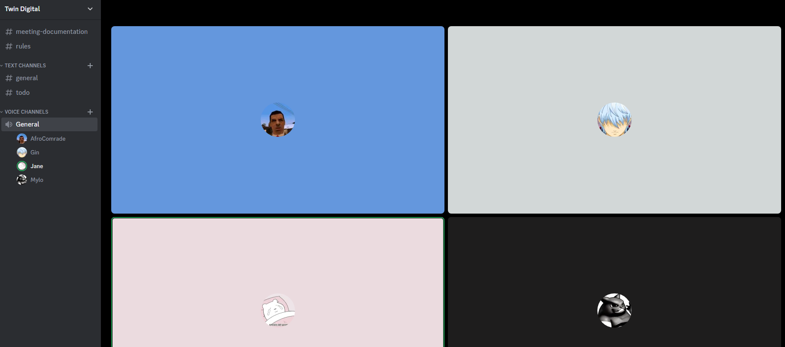

21. Today I had to revisit documentation in the proposal and tidy things up. I began to revisit the Terms of Reference and the Project rationale. This was due to the lines being quite blurred between the difference in them. However, I distinguished the main difference in the Terms of reference being the “what, how and who”, whereas the Project rationale is down to the why.   
  
22. Meeting online to fix proposal 25/03/2023, after Mathew suggested changes. We met online for the weekly meeting as planned. We went over some changes which Matthew suggested in the meeting beforehand. Most of the changes were to review the terms of reference and to remove a lot of the buzz words and target the terms of reference for the project.

23. After mentor feedback I began to review the Terms of reference once more, as it wasn’t entirely clear what this project is going to achieve or how. I began to condense down the what, how and the who in more detail than I previously had. I also included some linking sentences as the definitions were quite scattered. I tried to put a lot of work into the terms of reference as I believe this would have been a spotlight for the moderator in the proposal presentation.  
  
24. Meeting online Setting up presentation slides  
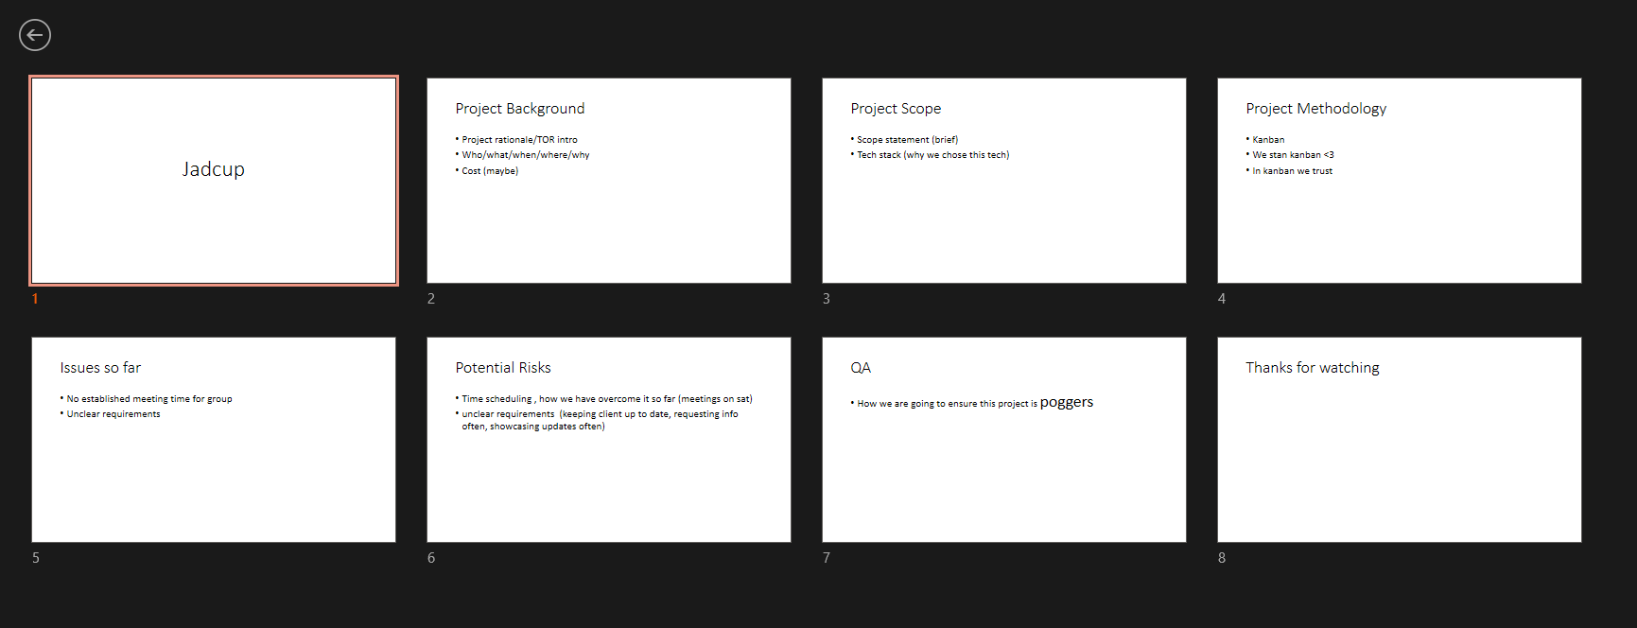  
We met online as usual during our 9:30am time slot on discord. This was to create our project proposal slides for the presentation. We allocated slides on what we would work/talk on.

25. Proposal review.

We met Matthew for the weekly mentor meeting which was for him to review the proposal and suggest any changes. He suggested we talk more about Kanban and justify why we chose this methodology for the project. He reviewed the updated terms of reference which I worked on. He also suggested we should discuss why we chose the selected methodology over methodologies such as Agile and Lean.

26. Finishing presentation, allocating slides to members, presentation reviews

We met online to go over the proposal presentation slides. We compiled the slides and went over them as a team. We allocated slides to each team member. I agreed to start the proposal presentation as no one else wanted to.

27. Final proposal changes, sending proposal to moderator.

We went over the final changes for the proposal and proofread what we had. We removed redundant headings and decided we would talk about the project background, project scope, project methodology, issues/risks, quality assurance, project timeline and the upskilling plan. We fixed the formatting. Josh sent the proposal to Tony and Matthew.

28. Meeting, quick rundown of proposal , printing sheets etc.,  
We met with Matthew to discuss finalizing the proposal before the presentation. He could not ask us directly what he would in the proposal but instead, presented us with some small feedback about what is good to include. We took this feedback and began to compile presentation after the meeting. A picture containing text, floor, indoor, ceiling

29. Project proposal  
We presented the proposal to Tony and Matthew in WZ1101. I began by opening with the introduction, however, as I am not the project lead, I felt quite annoyed about this as Josh is still quite adamant about being the project lead, but is not actually leading the group. In any case I continued with some technical issues which threw me off a bit and I did not open as strongly as I could. After the proposal was finished, Tony gave us some quite blunt feedback and stated we did not work together on the proposal as a team. This came as quite a shock as we felt we had spent a lot of time on the proposal together. The other feedback included that we did not have any milestones to keep us on track, which was justified as we had one 20week block of just ‘development’. We took this feedback away.

30. Amending proposal. Expanding on iterations and why we need to include specific milestones. We took the feedback we received and Matthew asked us to update the proposal before Wednesday 12/03/2023. We began to revisit the project schedule and include milestones which would keep us on track. We broke down our project schedule into 2-3 week iterations which included a milestone at the end of each iteration. We also updated the dates accordingly to fit to the schedule with no room for errors. We also included a small clause in the team contract that highlighted where and how we would work online due to the other members schedules being so busy.

31. I began upskilling by creating a Firebase account, which is our chosen platform on where we would host our website. I created an account and installed the appropriate libraries. I started by creating a React app which would be a static website just displaying some information and the users IP address.

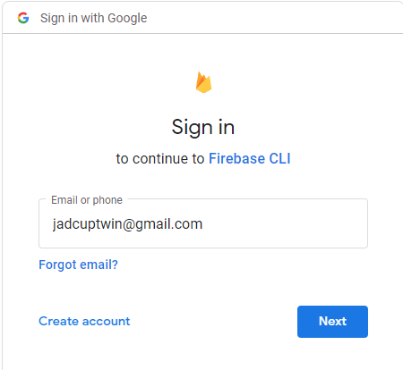

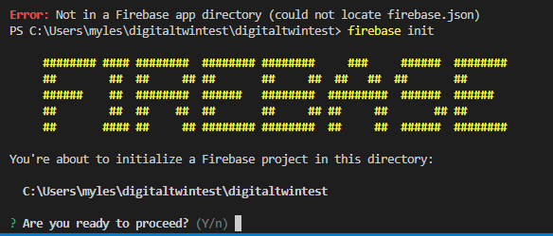

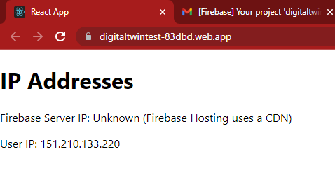

Above is the basic website which was successfully hosted on Firebase. The only problem was that Firebase now requires a ‘Pay as you go’ subscription for access to their command line functions. However, it seems as though for now the functions we will use will not accrue any costs.

32. Continuing upskilling. I began to research about a potential login system which utilizes Firebases built in database or fire store. However, I was not sure and needed to implement more research as the native database and fire store use a different style of functions for deploying information compared to SQL.

33. Proposal update, defining milestones and clarifying milestone report.  
We met online once again to finalize the proposal update before sending this back to Matthew and Tony. We changed a few of the milestones and due dates as we still had outlying iterations which did not include any milestones. Showed the group my website hosted.

34. Upskilling. I continued to work with the Firebase project and potential CLI prompts available to me. However, some did not work the way I intended. After some research I became aware that Firebase tools needs to have the highest execution policy to execute the powershell scripts. This was necessary to deploy the App directly to firebase via the CLI. I had to change the execution policy from AllSigned to RemoteSigned.



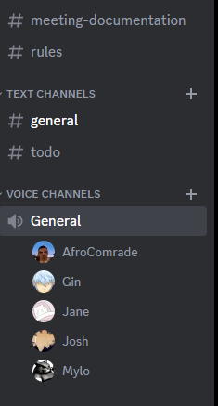

35. Upskilling (setting up firebase project, hosting a site, deploying through command lines, setting up react project with a link)

I continued to work on hosting the website and trying to ping the server on Firebase. However Firebase does not use traditional IP addresses and uses what is known as a CDN.   
A content delivery network. This is optimized for static information to be viewed very quickly.

36. Upskilling (setting up middleware program, middle is better for browsers as not all browsers can support PLC communication protocols, better to handle that in the middleware)

I continued to research about hosting the server online and came to learn that my current implementation would need another piece, which is know is known as middleware. Currently I thought that Factory IO would be able to send data directly to the website, however it is suggested this is not safe and not all browsers will support the protocols we will use to deliver data. In this case I created a basic middle ware program which will eventually be modular as the website can deal with just reading the data sent from the middleware program, and if any changes are needed, then only the middleware program needs to change. Reinforcing a modern modular approach.

37. Meeting

We met with Matthew online as agreed. We chose to meet over the break to make sure that the group was staying on track and keeping motivated throughout the break. I began the meeting by showcasing a test website which was deployed and hosted on firebase, which will be the final domain for the project’s web dashboard. I finished by stating what I would work on next which was attempting to connect factory io to the website someway. Yeran showcased his upskilling which was sending data from a middleware JavaScript program to factory io which was really helpful and coincided with my next steps.

38. Upskilling (attempting to connect factory io, trouble with ports and permission denial)

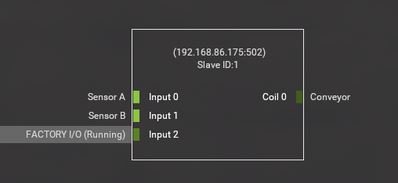

I created a template scene in factory io which would connect to a basic middleware program. Essentially this was trying to create a pipeline of data from Factory IO -> Middleware -> Website. I used a protocol called Modbus and imported the libraries into the middleware program. I also began by trying to host the middleware program on Firebase also which seemed to work. Factory IO uses a local IP address and a local port to transmit data over the Modbus protocol, the middleware application then uses that information to try to connect to the Factory IO simulation. However this did not work correctly as the IP address was local, and the middleware was hosted online, meaning the middleware program has no way of knowing where to find the Factory IO address. I looked into port forwarding my IP address to the router allowing the middleware to connect, however I still did not get a connection. I tried to use PostMan to directly access the middleware application however still did not connect properly.   
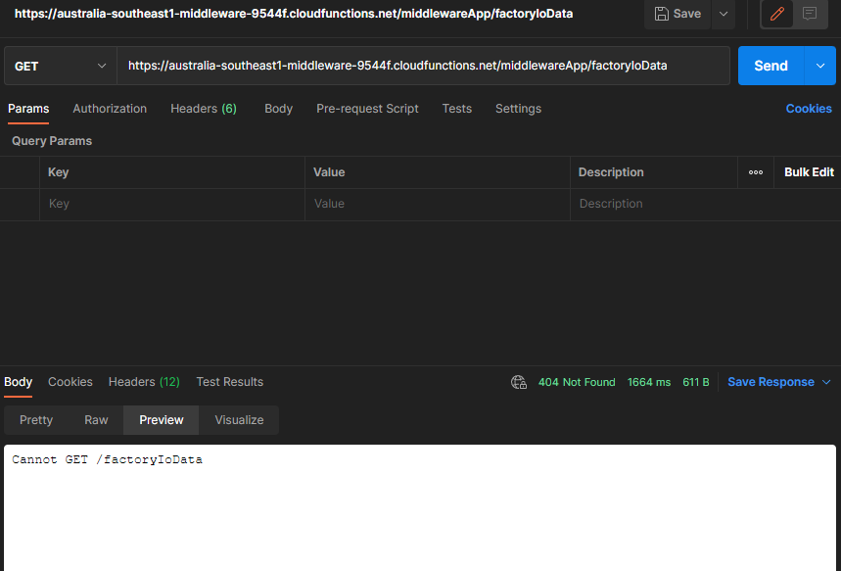

39. Upskilling. CDN network research. I began wondering why Firebase hosting was good for our project as it uses a Content delivery network. This serves content to users who visit the website from the server that is closest to them. Websites hosted on a CDN network help boost page speed and performances by utilizing a long cache time. CDN’s help reduce server load as they are distributed around the world by offloading data from the origin server. A CDN caches and compresses copies of a webpage which are then stored strategically at points of presence.  
  
https://rocketcdn.me/benefits-cdn/#:~:text=Distributed%20around%20the%20world%2C%20a,data%20from%20the%20origin%20server.

40. Modbus protocols. After having issues with the IP addresses and the template factory I/O scene. I began to look further into Modbus protocols to see if that was the problem.

<https://www.se.com/nz/en/faqs/FA168406/>

41. Meeting with Matthew during the break  
We met with Matthew online again in the second week of the break to discuss further where we are along in the project. I began the meeting by explaining to Matthew the technical issues I was having and attempting to connect IP addresses etc., he suggested using a RealTime Database which Firebase has already.

42. Began researching and setting up the real-time database. Initialized a new firebase project which would host the database. Installed firebase tools into the project and researched how to provide an endpoint to the website.

43. Upskilling

Working online. I continued to set up the RealTime database which would be responsible for storing basic data for FactoryIO. This RealTime database is the newest solution to storing data for FactoryIO and also for the web dashboard to read from. I created a new project and hosted the RealTime database on the Firebase account. This was relatively straight forward and seemed to work quite well. The next step was configuring the Firebase database credentials inside the Front End application. This was achieved by setting up a ‘listener’ to the database.

  useEffect(() => {

        const machineRef = ref(database, "factory_io/machines/elevatorAdvanced");

        const handleDataChange = (snapshot) => {

            setMachineData(snapshot.val());

        };

        onValue(machineRef, handleDataChange);

        return () => {

            off(machineRef, "value", handleDataChange);

        };

    }, []);

The above is the listener which is connected to the Database and will have access to any data at the time of the snapshot. The test data was then displayed on the frontend.

 <div>

        <h1>Machine Data</h1>

        <button className="button" onClick={testClick} children="Conveyor 1"></button>

        {machineData ? (

          <>

            <p>elevatorAdvanced</p>

<p>{machineData.coils.Conveyor0.name} : {machineData.coils.Conveyor0.value}</p>

<p>{machineData.coils.Conveyor1.name} : {machineData.coils.Conveyor1.value}</p>

<p>{machineData.coils.Conveyor2.name} : {machineData.coils.Conveyor2.value}</p>

<p>{machineData.coils.Conveyor3.name} : {machineData.coils.Conveyor3.value}</p>

          </>

        ) : (

          <p>Loading data...</p>

        )}

      </div>

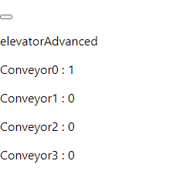

44. Upskilling. Realtime Database and concurrency. I began researching about if Firebase Realtime database would become an issue later. As we have a website which is continuously reading from the Database with one middleware client pushing data. However the website will have the potential to push data into the website aswell. I learned that Realtime database uses ‘optimistic concurrency control’ and has the scalability to allow for 200,000 simultaneous connections. Which is a lot more than we need. *Optimistic concurrency control (OCC) is a technique for managing concurrent access to data in a relational database management system (RDBMS). It allows multiple transactions to read and modify the same data without locking or blocking each other, as long as they do not conflict. OCC assumes that conflicts are rare and can be detected and resolved at the end of each transaction.*This means that our middleware program will not conflict with the website if they are reading/writing at the same time.[*https://www.linkedin.com/advice/0/what-benefits-drawbacks-using-optimistic-concurrency-control#:~:text=Optimistic%20concurrency%20control%20(OCC)%20is,as%20they%20do%20not%20conflict*](https://www.linkedin.com/advice/0/what-benefits-drawbacks-using-optimistic-concurrency-control#:~:text=Optimistic%20concurrency%20control%20(OCC)%20is,as%20they%20do%20not%20conflict)*.*

45. Team meeting online. We began by adding cards into the Trello kanban board, revising feedback, and considering if we’re going to act on it or leave it. A lot of the feedback for the proposal was completed and sent back to the moderator, which was then sent back with a new list of 5 additional changes required. We decided to talk to Matthew about this and decide how we would proceed. We discussed splitting up development tasks into smaller cards.

46. Mentor meeting at AUT. We showed Matthew the returned email from the moderator and the suggested changes. Which we decided we would revise and update before the Mid term review. We also discussed the possibility of buying the full FactoryIO license which was quite a pain point for the developers responsible for creating the FactoryIO prototype. The full license would let us use the required drivers for protocol communication, which the base edition does not provide.

47. As we no longer have RnD workshops, I decided to utilize this time and review the online Database format and it’s current JSON format.

As Yeran and I are using a new FactoryIO scene, we decided to use the above to store the data for each machine and current state.

48. Weekly online meeting. I had to leave this meeting early, however I took the time to show Jane the layout of the Database as she is responsible for reading the data and presenting the frontend. I showed her how the current frontend connects to the Database via the credentials and also the hierarchy of the Database.

49. Pre mentor meeting prep

50. Mentor meeting with Matthew

Email cup machine company about the settings manual for GC-800

51. We met online to work on further changes to the proposal which was requested by the moderator. One being the change management plan. Currently we are using Kanban which is a methodology focussed heavily on flow. We have a very strict and form-based approach to any changes which directly contradicts Kanban’s workflow. It was suggested that we work any changes directly into Kanban’s methodology. I began by breaking down what would be needed in a change if it was occur with Jane. We decided we would cover the projects design phases, high level, design, and iteration planning. We then came up with a way to implement any changes directly into the iteration planning. I wrote about how the changes would impact the current iterations and if it will affect the client, and if so, what procedures will take place. I also deleted the change management form as it was no longer needed.

52. Saturday meeting  
Proposal changes, change management review, risk management update, status report

53. Meeting with Matthew. Reviewing changes from Saturday asked more about kanban specific implementation. Showcased small demo on FactoryIO, showed prototype website. Matthew wanted us to look at enhancing the website further to pass lighthouse tests.

54. Teamwork, reviewing change management, focussing on process working into Kanban.

After the meeting with Matthew we worked together as a group while reviewing our change management update. The reason for the change was to rework our current change management strategy into a more coherent approach which fits into the Kanban methodology more correctly. Our previous approach was designed to use a lot of forms and waiting on approval, which directly conflicted with our methodology.

55. AUT workshop

Jacqui and Ramesh hosted a final workshop before our Mid Term project presentations were due. Ramesh briefed us on the expected quality of the report we should produce, and also covered the length of each deliverable. He also told what documents we had to include inside our portfolio.

56. Meeting about project status report

Discussing project status report, identifying what to include in our portfolio. Members leaving early.   
The team met on Saturday as per our usual time. The team discussed the project status report and what documents we should include. Jane had originally set up a draft template for us to use, we went over the marking rubric.

57. Meeting and working for Project Status Report

The team met early on this day as Matthew couldn’t make the meeting at the organized time. We continued to work on the project status report by completing the required sections.

58. Weekly mentor meeting with Matthew

We met with Matthew to show him and discuss our current status on the report. He advised us we need to go over the marking schedule thoroughly to get full grades.

59. Working on status report

I began working further on the status report as we assigned each member to particular parts to comb over and complete. I began by reviewing our iteration reviews and re-writing the executive summary. The requirements at first were not clear about the executive summary however I realized that the executive summary should be a condensed version of the status report and our current progress, and not a summary of the project in its entirety.

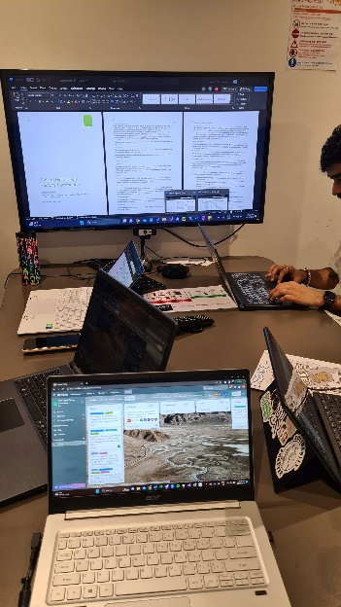

60. Creating component diagram for status report

I reworked the project description as it was too vague and did not go dive into detail about the project. I updated the executive summary more-so into a more formal writing style. I removed the table in the status report as the team members copied over all the risks and issues from the proposal, to reduce space and make the status report more coherent. I wrote about the 3 major risks we have encountered being the communication with the client, scheduling issues such as timetabling and the factory IO license. I created an appendix for the status report as our document was getting too large. I created a component diagram to represent our overall project. Team was meant to meet on this afternoon however did not.

61. Saturday meeting

Met with the team on Saturday to go over the report and make any further changes. We reviewed semester 2 timetables to ensure we would have enough time to meet. We discovered we could add an extra meeting day on Friday’s 2-4pm to combat the lack of meetings. We reviewed our Iteration review and milestone reports and decided it would be better to combine the two into one document.

62. Mentor meeting with Matthew

Status report is submitted, logbook catch up, discussion about PLC future? Unit test discussion about server, website,